Worthen with Shelve Parish Plan November 2013
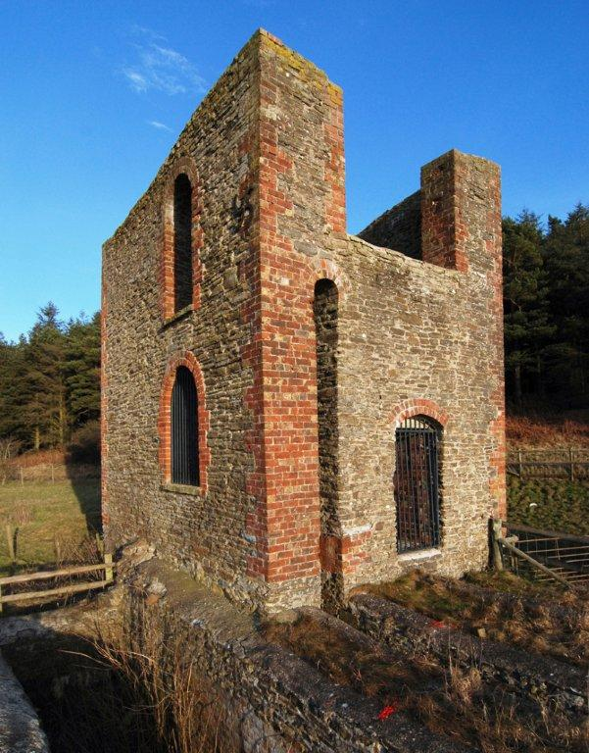
Contents
Introduction: What is a Parish Plan? 1
Summary of Findings 2
About Worthen with Shelve Parish 3
How the Parish Plan was produced 5
Housing and Development 7
Community Infrastructure Levy 9
Young People, Play Areas and Schools 11
Employment and Training 14
Leisure and Recreation 14
Communications 16
Sustainability and the Environment 17
Community Services and Activities 19
Crime and Safety 22
Healthcare 23
Footpaths and Pavements 24
Tourism 25
Appendix i
Implementation Plan i
Local Implementation Plan Error! Bookmark not defined.

Pictures copyright & courtesy of Dave Croker and Andrew Jones.

Introduction: What is a Parish Plan?
“A road map produced by the community with specific destinations.”
A Parish Plan is a document designed to enable the people who live in a parish to express their opinions about how they see their community and environment and to say how they would like it to evolve.
Our villages and the surrounding countryside are changing all around us. Most people have strong views on whether this change is for the better or the worse, but unfortunately for the vast majority of individuals this is as far as their involvement will go. Hopefully, the Parish plan will give everyone in the community the opportunity to influence the development of their surroundings and local amenities.
The Parish plan is intended to be an evolving document, outlining how the parish would like to develop over the next few years and longer, and includes an action plan detailing how these developments can be achieved. It can be regularly updated to reflect changes in the community’s views and needs.
The Parish Council will be able to use the information as a basis for decision making. Worthen with Shelve Parish Council holds monthly meetings which rotate around the three wards in order to allow for public input into its decisions. In reality there are usually few attendees at council meetings apart from the councillors and so the Parish Plan will enable the Council’s decisions to reflect the community’s views with accuracy.
As a result of changes such as the Localism Act (part of the Government’s strategy to give local communities opportunities to influence the future of the places where they live), every community in the country is being encouraged to produce a Place Plan such as this Parish Plan. Now that our Parish Plan has been drawn up, not only the Parish Council, but also the Shropshire Unitary Council, will need to take note of the objectives and opinions stated in it with regards to planning and other changes. The Plan will also be used to inform decisions on how money from the Community Infrastructure Levy is spent in the community, when this starts to be paid by developers building new houses.
People may feel sceptical about how much real influence a Parish Plan will have over decisions about planning and local services at county level – and it remains to be seen how this will work out in practice – but at the very least it will make local authorities aware of what we consider important and what improvements we hope for in our local community.
Some of the information gathered during the questionnaire exercise is already being put to good use. It has been taken into consideration during decision making by the Parish Council, for example a Shropshire Council Local Implementation Plan for housing has been ratified by the Parish Council stressing the need for lower-cost, affordable smaller houses to be built as infill, rather than executive houses on estates.
The Stiperstones and Corndon Hill Country Landscape Partnership have recently been awarded a sizeable grant for their heritage and conservation scheme, and the Parish Council is one of the partners which will feed in local views based on the Parish Plan.

Summary of Findings
The largest housing need is affordable housing for local people to buy or rent, and for 2 or 3 bedroomed homes. There is also a need for sheltered accommodation for the elderly. Smaller developments on infill sites are preferred.
The Community Infrastructure Levy, which is a charge on new developments, should be spent on young people, roads and pavements, and community amenities.
Village primary schools are seen as very important assets to the community. There needs to be more activities provided for young people outside school. More play areas for younger children. Young adults need more assistance to find suitable work.
Television reception is adequate, radio reception is less reliable. Mobile phone connection is poor – and 95% of respondents still have a land line. Many people would like a faster broadband connection.
Dog fouling, litter, and fly tipping are seen as problems in the area. Many people would like to take part in an annual “tidy up” day.
Recycling and energy saving measures are seen as important, but more could be done to improve these. Improved broadband would mean more people could work at home. There is considerable interest in a community bulk heating oil buying scheme.
More could be done to publicise local events. Community services such as local shops and mobile library are seen as important but are not always supported as much as they could be by the local people. There should be more sporting facilities in the parish.
The main problems are speeding traffic in the villages and anti-social behaviour. The Rural Watch scheme and greater police presence would help most with such problems.
Most people use the doctors’ surgeries in Worthen and Pontesbury. Additional services such as physiotherapy and chiropody would be welcome.
Footpaths are poor in certain areas, with fast traffic making walking dangerous particularly for children. Requests for improvement are being submitted to Shropshire Council by the Parish Council.
Tourism is an important source of employment and income in the parish, and relies upon our unspoilt natural features – much of the parish is within the Shropshire Hills Area of Outstanding Natural Beauty. There is good provision for tourists, with high quality, small-scale accommodation and tourist centres at The Bog and Snailbeach. Public conveniences need to be maintained or provision increased.
With the reduction in bus services there is increased reliance upon use of private transport, which in turn increases costs for those wishing to live in the country but needing to commute for work. This puts an increased strain on younger families who are needed within the parish in order to retain basic services such as schools and shops.

About Worthen with Shelve Parish
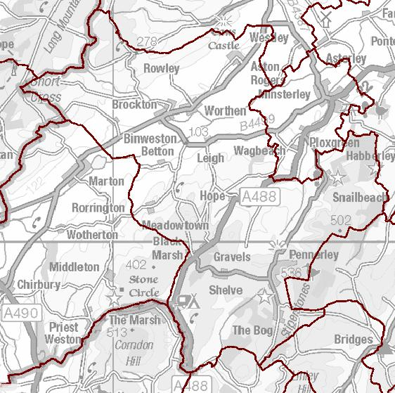
Figure 1 Parish Map
Worthen with Shelve Parish is geographically one of the largest in Shropshire. Most of the Parish is situated within the Shropshire Hills Area of Outstanding Natural Beauty.
There are three wards in the Parish. The villages of Snailbeach and Stiperstones together with a string of hamlets which lie along the western flank of the Stiperstones range of hills in south west Shropshire make up Heath Ward. Hope with Shelve Ward extends from The Bog road, along to Hemford, encompassing Bentlawnt, Hope Valley, Hogstow Hall, Drury Lane, Shelve and Santley. The Worthen Ward stretches from Aston Rogers, through to Worthen and Brockton, to Binweston.
Worthen with Shelve falls within the UK Parliamentary Constituency of Ludlow, the Unitary Authority Electoral Division of Chirbury and Worthen, and within Bishop's Castle, Chirbury, Worthen & Clun Local Joint Committee area.
The western boundary of Worthen with Shelve Parish runs along the Welsh border from north of Rowley Hill down to Flying Ditches west of Binweston, where it meets the Chirbury parish boundary, as far as the turning for White Grit off the A488. The boundary (at this stage formed by the River West Onny to the west of the A488), then runs along the Welsh border again before turning east at Nind. The boundary runs south of Nind and then turns north east, leaving Cranberry Rock to Ratlinghope Parish, before running along the top of the ridge of the Stiperstones, literally through the middle of the Devil’s Chair. It encloses Snailbeach and Eastridge Wood and then turns back towards the Hope Valley, hitting the A488 just south of Wagbeach. The boundary then runs northwards, taking in Aston Rogers and Mondaytown before turning west towards the Welsh border at Rowley Hill again. The ancient tradition of walking the parish boundary, known as Beating the Bounds, would probably take quite a while.
The country encompassed by this parish boundary is varied - the low-lying fields of the wide, flat Rea Valley, which are often flooded during long, wet winters, are surrounded by fertile, green hills, which contrast with the rocky, heather-covered uplands of the Stiperstones. The area is geologically very interesting. The distinctive shape of the Stiperstones ridge is a result of the hard quartzite stone from which it is formed and the fact that the ridge remained above the glaciers during the last Ice Age. The Stiperstones is a National Nature Reserve and Site of Special Scientific Interest (SSSI), with many native birds and plants of interest, such as Red Grouse and the increasingly rare Mountain Pansy.
There are also veins of igneous rock containing valuable minerals such as lead, zinc, barytes (and even some silver). Lead has been mined in the area probably since the Bronze and Iron Ages, and certainly since Roman times, notably at Snailbeach and Roman Gravels. Lead mining increased in the late 18th century and for nearly 100 years Snailbeach was the most profitable lead mine in the country. In 1910 lead mining ceased, although barytes continued to be mined until the 1930s. The mining industry meant that the population of the area used to be much higher than it is now - as indicated by the high density of pubs that sadly no longer exist…
There are signs of habitation and land use throughout the Parish from prehistoric times onwards. There are hillforts dating from the Late Bronze Age and Iron Age (about 1200 BC) on the Stiperstones and near Meadowtown. There are remains of a Roman fortification on Rowley Hill and of a medieval motte and bailey along Drury Lane, examples of the many defensive constructions throughout the area, a result of the turbulent history of the Welsh Marches (ie the Welsh borderlands), particularly during the rule of the Marcher Lords in the 12th and 13th centuries. During the English Civil Wars, Leigh Hall was a soldiers’ garrison and the 14th century manor house was burnt down when the Royalists had to abandon it, so that it could not be of use to the Parliamentarians.
The area, particularly the Stiperstones, has featured in the writing of Mary Webb, D H Lawrence, and the childrens’ author Malcolm Saville. There are numerous legends associated with the Devil’s Chair and Edric the Wild, who was a Saxon earl who valiantly fought the Norman invaders for decades .
The main industries now are agriculture and tourism and associated trades. Farming is mainly dairy with some arable, and sheep on the higher ground.
There are tourist centres at Snailbeach Mine and Bog Visitor Centre, though the whole area is attractive to tourists and there are a wealth of b&bs, holiday rentals and inns offering accommodation for visitors.
The total population of Worthen and Shelve Parish was estimated to be 2,004 in 2008. Worthen/Brockton is the largest settlement in the parish, with an estimated population of 609. There are two other settlements in the parish; Snailbeach (134) and Stiperstones (59). On the whole the area has a slightly older age structure than the county average, although the percentage aged 0-15 is slightly higher than the county average. The over-45 age groups make up a higher percentage than the county, regional and national averages. The working age population accounts for 60.5% of the total compared to 58.2% in Shropshire, 60.9% in the West Midlands and 62.1% in England. (Source: ONS MYE Population Estimates 2008)
In 2001 69.7% of the population aged 16-74 were economically active (compared to a county average of 68.7%, a regional average of 65.9% and national average of 66.9%). The local people are generally highly skilled. The proportion of people aged 16-74 who have no qualifications is lower than the county, regional and national averages. (Source: 2001 Census)

How the Parish Plan was produced
Worthen with Shelve Parish Council applied for funding in 2011 to produce a Parish Plan for the area. This, in part, came about due to the formation of Shropshire Unitary Council and the proposed Community Infrastructure Levy, the Localism Act and the feedback received from members of the community.
A number of public meetings were held across the Parish in order to publicise the idea of creating a Parish Plan, to ask people to identify the local issues that were important to them, and find volunteers to form a Parish Plan steering committee. The committee, formed by volunteers from all three wards, drew up a questionnaire which was hand-delivered to all households, and was also available to complete online. News items about the Parish Plan survey were placed in all the local newsletters.
In total 932 forms were distributed ( Heath 259, Hope & Shelve 275, Brockton & Worthen 398), and a total of 269 forms were completed, which is a respectable 30% response rate. Figure 1 shows the responses by Ward and local centre (where indicated). The results from this survey are incorporated into this report.
Figure 2 Number of Returned Survey Questionnaires
In total 932 forms were distributed ( Heath 259, Hope & Shelve 275, Brockton & Worthen 398), and a total of 269 forms were completed, which is a respectable 30% response rate. Figure 1 shows the responses by Ward and local centre (where indicated). The results from this survey are incorporated into this report.

Figure 3 Household Age Range

Figure 3 shows the range of occupants of the responding households by breakdown of age within the household.

Housing and Development
Over the past ten years approximately 80 houses have been built in the Parish. The majority of these have been executive style properties on estates, in each of the larger settlements. Whilst some of these properties have attracted families to the area and encouraged people with local links to return, the majority are either rented or occupied by two people. The Parish Council, using the parish plan data, produced a Local Implementation Plan for the parish, which will hopefully deliver the type of open market housing that is required.

Housing Needs
The largest housing need identified is that for affordable housing for local people to buy or rent and for small starter homes – over 50% of respondents identified these two categories of homes.
Figure 4 Housing Needs

Two and three bedroom houses are seen as important for people on the way up and down the housing ladder – providing opportunities for people to start in a small way as well as allowing older people to downsize.
Suitable sheltered accommodation is seen as a priority slightly ahead of family homes, indeed there are several references in the comments section to the closure of such accommodation locally.
50% of respondents see a need for more rental properties which reinforces the requirement for affordable housing.
The comments range from clarifying the term ‘affordable housing’ to a number calling for no more housing to be built at all.
Sample quotes are:
“Housing that is affordable but not ‘affordable housing’”
“Housing that is affordable by all but not designated as affordable”
“Affordable family homes”
“Eco-friendly”
“No extra housing”
“More housing will spoil the character of the area”
“I don't know the need but with so many houses on the market for 3/4 years?”
“For a start it needs the houses that are in the area to be all lived in not just second homes for the well off.”

Number of Homes and Development Size
Up to 25 homes for development within the next 15 years within the Parish is supported the most by those who responded. Taking into account the number who wanted more houses than this, the Parish Council opted for scheduled quotas on each Ward for the next 15 years. This is detailed in the Local Implementation Plan in the Appendix . As this goes to press (Dec 2013), Shropshire Council have informed the Parish Council that wards cannot be clusters. In order to implement the desired planning a cluster of named settlements in each ward will replace the concept of ward allocations.
Figure 5 Numbers of Homes over 15 Years

In addition to the total number of houses to be built, parishioners were asked how big they would want the biggest development to be, which is reflected in Figure 6.
Figure 6 Size of Development
Number of Homes in Development
Two in three people would like to maintain the ‘green buffer field’ between Worthen and Brockton.
It is clear that smaller size developments, rather than one large scale development, are supported by all.
In the survey about any other related issues 42% generally expressed views in favour of controlled, small, “in keeping” development whilst 13% were against any further development at all.
15% actively supported affordable housing and 10% were concerned about the requirement for infrastructure development.
Finally 1 in 5 of the respondents from Worthen criticised the South Shropshire Housing Trust for abandoning the properties in Old Mill Close for a number of years when they could have been occupied.

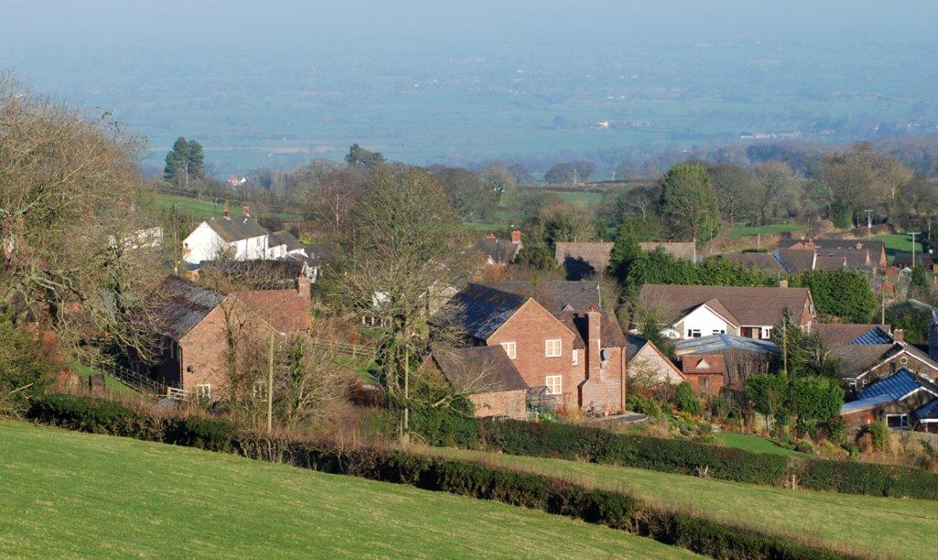
i Above Bentlawnt

Actions: Ensure Local Implementation Plan reflects local housing needs, and encourage developers to work within that plan
Encourage renovation and redevelopment over green-field use
Promote smaller houses (2 &3 bedroom) in small speculative infill sites.

Community Infrastructure Levy
The Community Infrastructure Levy (CIL) is a charge on new developments. Some of the money is passed for the local community to spend as determined locally. When surveyed as to how the CIL should be spent 67% of those who responded indicated that the funds should be spent on young people, roads and community amenities.
Overall 27% said that there was a need to fund projects for young people particularly youth schemes such as youth clubs, pre-schools and junior schools.
Roads were cited by 22% of respondents as needing funding for improvements and maintenance – with different priorities depending on location. Speeding traffic being the major issue on the B4386 (Worthen and Brockton) and A488 (Hope), with ditch, hedge, potholes and passing places being of importance on side roads into the hills.
Community amenities centre around the village hall or community centre and the shop and or Post Office. 18% of respondents would like to see Community Infrastructure Levy funds support these two amenities. There is a long shopping list of other items in this category which may be considered on a case by community basis as the suggestions seek to solve specific issues for the community e.g. notice boards, community enterprise, leisure facilities.
The rest of the suggestions tend to be more localised.
Rights of Way and Pavements – in Brockton and Worthen approx. 15% of the respondents highlight the need for improvement and extension of pavements through and between the villages. Whilst in Hope 7% also highlight pedestrian safety issues.
Figure 7 CIL spending priorities by location (as % of respondents)

The environment is identified by 8% of the respondents as an area requiring investment, particularly in Hope and the Stiperstones: litter; maintenance of streams and drainage ditches; energy saving funding; and wildlife protection.
Finally there is a list of other issues which are mentioned by fewer than 8% of the respondents – for completeness however these are listed below:
Public Transport – consisting of either retention or improvement of service or suggestions of additional services for remote communities.
Allotments, community gardens and orchards – this was mentioned by 10% of respondents in Brockton and Bentlawnt. However this was an example suggestion in the questionnaire and so its popularity may be skewed by this reference.
Support and amenities for the elderly was mentioned by about 3% of the respondents.
A few respondents did question the consequences of implementing the Community Infrastructure Levy and suggested that it would stifle the type of development the community seemed to desire i.e. the policy would favour commercial development of an ‘estate’ style – and discourage single dwellings and ‘self-build’.

November 2013 review
At the preview meeting of the Parish Plan in November 2013 held at Hope Village hall, all the suggestions for use of CIL put forward from the questionnaire were displayed, and attendees asked to vote for their favourite suggestions for their part of the parish. These are detailed below:
Bentlawnt
Support for local shop/PO
High speed Broadband
Salt bins, Bentlawnt
Brockton
Public transport
Pavements
Youth facilities
Community Projects
Hope
Traffic calming A488
Public footpath access
Hedging & ditching
Gritting & snow clearance
Road improvements
Snailbeach
Toilets
Footpath to School
Sports Facilities
Stiperstones
Broadband
Use brown field sites
Worthen
Keep school & shop open
Upgrade footpath facilities
Pavement improvements
Elderly people’s accommodation
Preserve beauty of area
Maintain streams & ditches
Actions: Encourage community schemes beneficial for locals by requesting ideas for funding
Support village halls

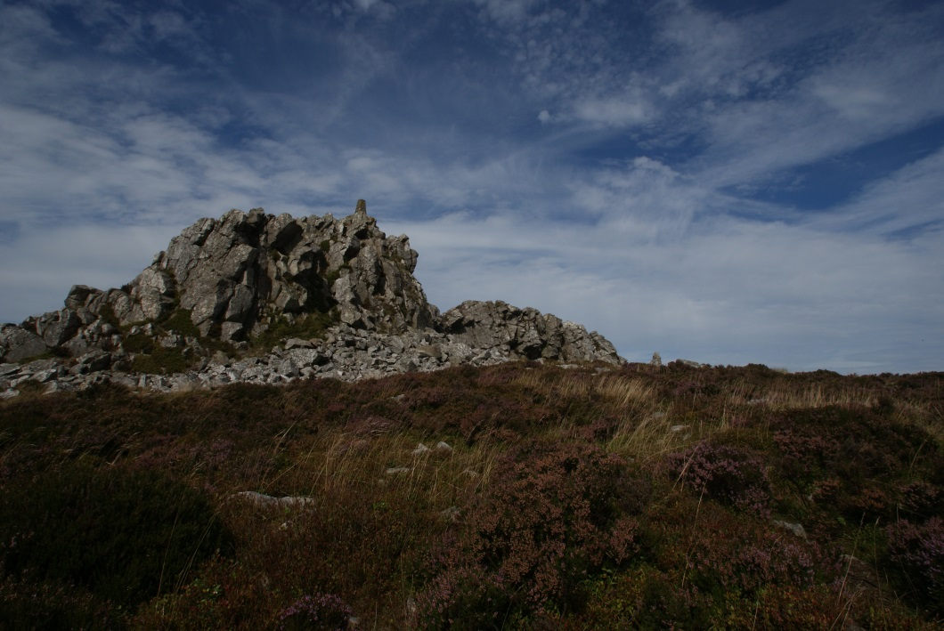

Young People, Play Areas and Schools
The Parish is fortunate in having a primary school in each Ward at Worthen, Hope and Stiperstones. These are viewed as being a lifeline for the community as young families are unlikely to want to live here if their young children have to travel excessive distances. Stiperstones, Hope and Worthen also have pre-school facilities, the latter based in the Village Hall.
Snailbeach, Worthen and Brockton have children’s play areas maintained variously by the Village Halls and the County Council.

Schools
Worthen School employs 3 full-time and 1 part-time 0.4FTE teachers, also 3 part-time teaching assistants and 2 part-time administrators. There are 65 pupils with the youngest 4 and the eldest 11. The current school was built in 1986 (with alterations in 1996 and 2007) but Worthen has had a school since the mid-19th century. The school has playgrounds, playing fields and an Ecolab. School premises are used for a Breakfast Club from 8-9am, and After School Club 3.15pm - 6pm
Worthen School was awarded Eco-School Green Flag 2012 (for the 4th time!) Healthy School Award 2009, Safer Schools Award 2010
Website: www.worthen.shropshire.sch.uk
Hope School employs 2 full-time teachers, 2 full-time Teaching Assistants , 1 part-time Teaching Assistant, 1 full-time site manager, 1 full-time administrator, a part-time music teacher and weekly sports coach. There are 39 pupils (4 – 11 years) in two classes and a further 10 (2 – 4 years) children in the pre-school (Hope School Young Explorers). Breakfast Club and After-School Clubs take place Mon-Fri. The school has a covered, outdoor play area, a large sports field with play equipment, a tarmac playground, gardening areas, habitat areas, (including a pond). The multi-sensory garden and woodland area are developed through the Forest School initiative. There is a well-equipped library and a hall for P.E. and drama. Hope Village Hall which is next door is used by the school for larger events. The school provides a daily mid-day meal, cooked on the premises.
Website: www.hopeschool.co.uk
Stiperstones School is part of the Chirbury Stiperstones Federation which was set up in January 2012. The school employs 2 full-time teachers, 1 part-time teacher, 5 part-time teaching assistants and 2 part-time administrators. The school also now runs Stiperstones Pre-School which employs 3 part-time staff. There are 38 pupils (4-11 years) in the school and 3 pupils in the pre-school. There is a covered outside play area for Key Stage 1, Foundation and Pre-School pupils, a larger outdoor play area for all children and a sports field. The school regularly uses the local surroundings, including the nature reserve, to support outdoor education. There are 2 classrooms, a hall and a library area. The school has achieved several awards over the years, such as Activemark 2007, Safer School, Healthy Schools, FMSiS and John Muir Discovery and Explorer Awards.
Website: www.stiperstones.shropshire.sch.uk
98% of the respondents believe that the schools should be kept open and 69% believe that they should be open for community use outside school hours. The most popular additional uses of schools were: breakfast and after-school activities for school children; youth activities; sporting and leisure activities; other education classes e.g. night school.
Example comments are:
“Possibly for computer access and courses, something that’s difficult in the village hall”
“Abermule school is a perfect example as it is used for many out of hours activities, e.g. Bowls club, patchwork and quilting, WI”
“Evening classes and educational activities would bring life to the area”
84% of those who expressed an opinion said the pre-school provision in the parish was adequate, however there was a more mixed response to provision of before and after school clubs with an 84% satisfaction in Worthen Ward dropping to 69% in the Heath Ward and 59% in the Hope Ward.

Facilities for Children and Young People
Just less than half( 48%) of those who expressed an opinion said they were satisfied with the provision of activities for young people.
Example comments are:
“Pre-school only 3 days; before and after club very small room and unfair on children. Very little activities for children out of school”
“We desperately need more activities and training for our young villagers”
“Sporting facilities, indoor and outdoor”
“Nothing is organised in villages for school holidays”
“Before/ afterschool clubs, unsuitable currently though the Stiperstones school offers free clubs till 4.30 twice a week”
“There is no youth club for teenagers in Stiperstones”
Actions: Encourage provision of pre-school and after-school clubs, and holiday provision.
Investigate setting up Youth Club in Stiperstones.

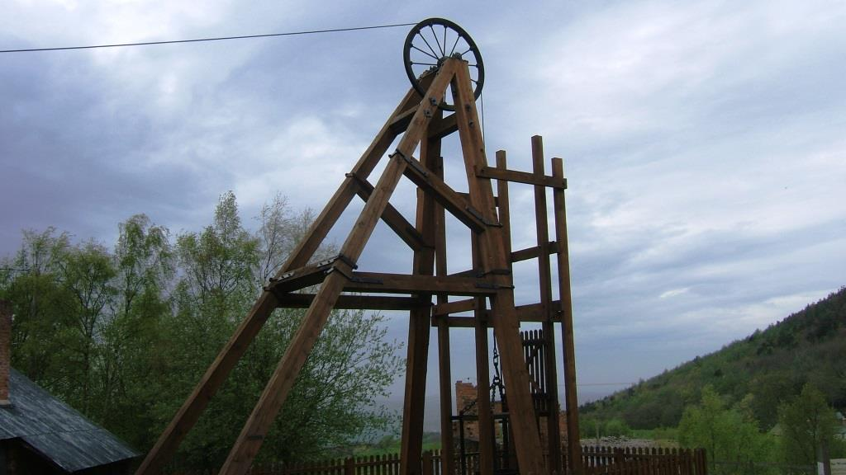

Employment and Training
With regard to employment for young adults, 60% of respondents identify young adults who wish to remain in the parish and 94% identify a need for more local employment opportunities. 88% see that there should be more help and training for young people to find work.
The suggested solutions include better transport, support in finding jobs, generation of apprenticeships or internships, and schemes to support local businesses.
Example comments are:
“Larger incentives for local employers to take on school leavers. Help towards transport costs across our area. Not everyone wants to drive. The link bus is not regular enough to rely on.”

“Advice on writing CV's. Courses designed to increase motivation and self-esteem”
“Opportunities for practical work experience, local relevant training and apprenticeships” (6 comments)

Actions: Improve local training opportunities through Landscape Partnership
Assist youngsters find suitable work by setting up a mentoring scheme

Leisure and Recreation
WORTHEN WARD
Worthen Village Hall and recreational field. Play area located to the rear of the Village Hall
Regular events:- Youth Club for Y6 to 16 every Thursday. Mums & Tots, Upholstery, children’s dancing lessons, short mat indoor bowling, WI,
Seasonal and occasional:- New Worthen Players and productions, quiz nights, bingo, cinema, various AGMs, two gardening shows a year, the Church Fete, gigs and concerts, table top sales and craft fairs, consultation events, children’s parties, birthday and anniversary celebrations including wedding receptions.
Callow Café is bi-weekly on a Friday at the Methodist Chapel
Brockton & Worthen Crown Green Bowling Club has regular games and practice
Brockton Rovers Football Club - adult and junior teams
HOPE WARD
Hope Village Hall, where a Youth Club meets 2nd and 4th Fridays of the month during term time. It runs from 7-9pm for children from Y6 until the age of 16
Hope Village Hall is used to host gigs and concerts, whist drives, bingo, Samba Band, Clinical Pilates, Zumba and receptions. Being adjacent to the school, events such as Hope Show use both facilities, and the school uses the hall on occasion for things such as PE
HEATH WARD
Snailbeach Village Hall
Regular events:- Brass Band practice, Quiz, Whist drives, Dog Training, WI, Bingo, Dancing Classes, Art Classes,
Seasonal and occasional – Art Show, Shropshire Wildlife Trust events, Shropshire Mines Trust events, Natural England events. Birthday parties, funeral receptions, wedding receptions, Stiperstones School events, music evenings, & drama events
In addition to the Village Hall there are:-
- Snailbeach Mine which is open for visitors.
- The Bog Visitors Centre, with about 18,000 visitors each year.
- Stiperstones Inn for open broad band “Broadplace”.
- Snailbeach football club
36% of those who expressed an opinion think that the provision of leisure, recreation and play area facilities for young people is inadequate across the Parish. This rises to 52% being dissatisfied in the Hope Ward.
Approximately one in four respondents considers that the play areas are inadequately maintained. Whilst 68% consider that there is a need for additional equipment.
Example comments are:
“Play in the countryside, all the equipment needed is provided by nature”
“Play equipment - for older children e.g. BMX track, zip wire, MUGA”
“No play provision for under 16's in village (need use of car to Snailbeach) - Although there is a play area in Snailbeach there are no facilities in Stiperstones. Local children need a communal area to meet and play”
“Play equipment in need of updating. Been maintained by village hall and volunteers. Needs grants to help and replacement goal posts”
“No recreation facilities in Bentlawnt. Have to travel to Stiperstones or Minsterley”
“No recreation ground in Hope but Worthen and Minsterley recreation grounds are not used”

Actions: Improve access to play facilities in Hope and Stiperstones
Upgrade village hall facilities so that more groups feel able to use them

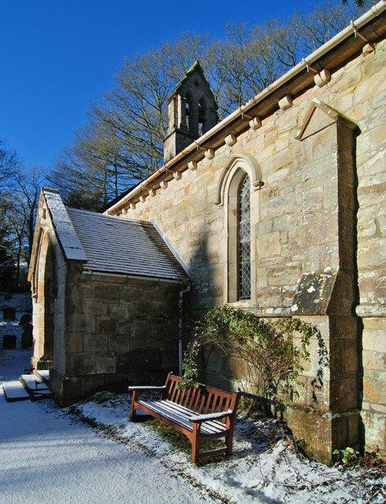
Communications
Electronic communications in the parish are severely hampered by the topography and geology. Topography means that in many parts of the Parish hills block out transmissions, while quartzite rocks absorb radio signals.
To alleviate these problems, television can be obtained by satellite and telephone is dependent upon landlines. However large distances to local telephone exchanges mean that broadband over copper wire is severely degraded – 5 miles to an exchange can give virtually no connection. Fortunately a local firm provides broadband via a series of microwave link dishes using a line-of-site geometry. Radio reception can be very transient – at times Radio Manchester can overwhelm Radio Shropshire – or Radio WM can be stronger due to the lie of the land.
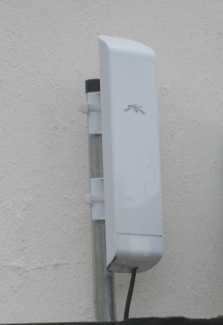 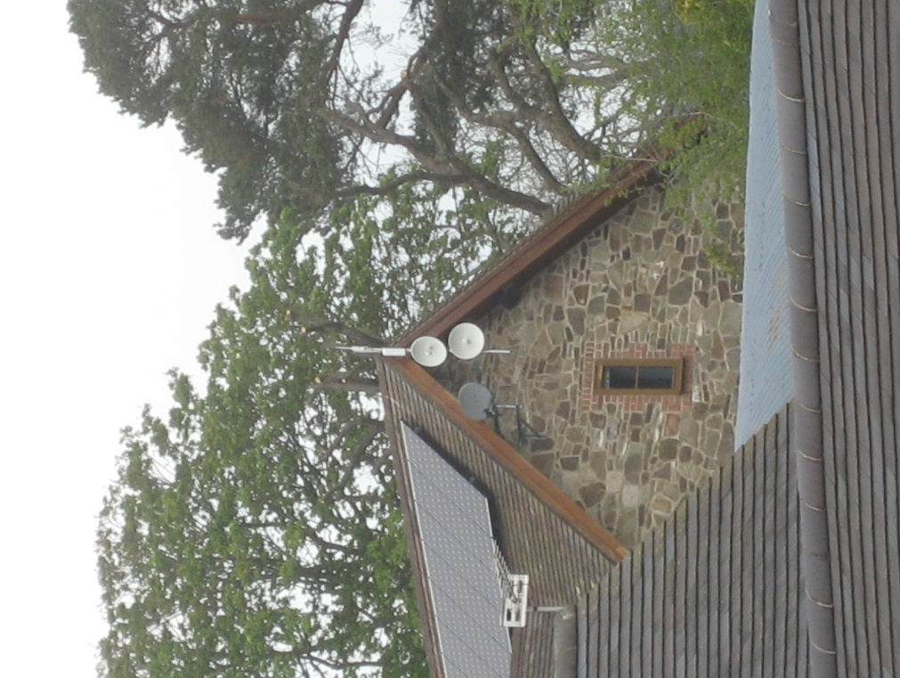
Figure 8 Microwave broadband receivers
95% of respondents have a land line, particularly important as 62% describe mobile phone connection as poor. 83% have a reasonable internet connection and 93% of those are on broadband. 30% would be prepared to pay for a faster connection, which those using the SWS service already do.
Approximately 2 in 3 people have poor mobile reception service.
1 in 3 respondents do not reliably receive emergency information from BBC Radio Shropshire.
85% of respondents have reasonable TV reception and this falls slightly to 80% when it comes to radio and drops to 39% using DAB with 15% having no signal for this service.
Figure 9 Public network broadband speeds
Actions: Lobby for improved Broadband services, TV, radio and mobile phone coverage

Sustainability and the Environment
Sustainability means enabling community development to happen within environmental limits and takes into account community aspirations; considering the wider impact on not only the natural environment and biodiversity, but the way people live in and use the environment for social and economic gains.
Although a global issue, our actions should take into account the changing climate and our long term actions should ensure that our community is resilient to a climate that may include warmer summers, wetter winters, and more extreme events.
This survey shows that there is still a lot more that residents can do to improve the energy efficiency of their homes.
Renewable energy sources such as solar PV and hot water are strongly supported, but there is little support for large wind turbines.
The variety of kerbside collection of recyclables in Shropshire is on a par with other local authorities and the Council has recently increased the types of plastics that can be put out for recycling. However, recent changes in EU legislation forced the removal of kerbside collection of cardboard with the green garden waste, due to potential issues relating to inks used in the packaging industry.
Large cardboard collection containers have been located around the county but there are none within this Parish, which means residents either revert to putting it in the black bin for landfill or they have to transport it to a cardboard collection site outside the parish.
Approximately 1 in 3 of respondents sees a problem with unsupervised dogs whilst 2 in 3 see an issue with dog fouling.
64% of respondents see an issue with fly tipping but this rises to 85% when considering littering within the parish. 90% are in favour of a “tidy up” day once a year.
Recycling facilities are considered important by 92% of the respondents.

Figure 10 Respondents with energy and water saving measures*note –rain water harvesting probably refers to the use of rainwater butts as opposed to engineered harvesting systems
56% of respondents are interested in community bulk heating oil buying schemes.
Figure 11 Respondents’ support for renewable energy and heating sources
The following are % of respondents who have these new technology heating sources for their homes:
- Air source heat pump 2%
- Ground Source Heat Pump 0%
With regard to road verges, 2 out of 3 respondents say they should be mown and kept tidy whilst just over a third want them to grow to promote wildlife. Three quarters of respondents consider it important to prevent vehicle damage to road verges.
83% of the respondents see value in planting more trees.
77% of respondents are in favour of maintaining gates, stiles and bridges; whilst 99% see value in the maintenance of ditches and gulleys.
Figure 12 Support for sourcing locally grown food
87% of respondents are in favour of turning street lights off between midnight and 5 am and 97% support investment in energy saving technologies for street lighting.
With regards to the proposed National Grid Mid Wales (TAN8) connection through the parish 70% of respondents are strongly against the installation of pylons and above ground cabling; whilst 89% support the under-grounding of such cabling.
In order for there to be jobs within a rural environment, certain businesses need to be encouraged. Working from home is a major preference, but in order for that to function basic services such as Broadband need to be in place. Looking at Figure 9 Public network broadband speeds, it can be readily seen that the Parish is at a significant disadvantage to a larger community. Figure 13 shows respondents preferences for development of local businesses.
Figure 13 Respondent’s reaction to development of businesses and working practices within the parish
Actions: Press for improved Broadband to enable home working
Provide recycling facilities to complement kerbside recycling
Implementation of power-saving measures for street lighting
Promote local and national tree-planting schemes
Promote facilities for small scale business development
Promote locally grown and sourced produce through “buy local”
Promote bulk heating oil schemes.

Community Services and Activities
Worthen Ward has All Saints Church, Worthen, a Methodist Chapel, and Brockton Church, which is completely run and financed locally.
Hope with Shelve Ward has two Church of England churches - one at Hope and one at Shelve, Heath Ward has a Methodist and a Baptist church in the Ward. All hold regular services.
The Mobile Library calls on a regular route every fortnight, stopping throughout the parish.
Three different newsletters carry information – Snailbeach, Hope and Worthen Newsletters which are generally supported financially by the Parish Council. Each is run independently of each other, profits from Hope adverts go to the Village Hall. It has been noted that the areas often do not publicise events very widely and the Parish Council is looking into listing events from all three wards on their website.
The Parish Council recently paid for a public notice board to be fitted on the Public Toilets in Snailbeach.
Figure 14 Marketing for local activities
96% say they find out about activities through their local newsletter, yet 32% of those who answered said they would not be happy to contribute to the printing costs of a newsletter. Similarly almost unanimous support is provided for the local shop, village hall and Post Office, yet many take their custom elsewhere.
With the Mobile Library service just over one-third actually use the service but with only 18% of respondents using it on a regular basis.
Reasons given for not using the service were mainly
- Village Halls – Access and acoustics
- Places of Worship – Not religious
- Mobile Library – with withdrawal of service, access library services in town, working during the day
Figure 15 Importance of local assets and services
Figure 16 Respondents’ usage of services

Example comments are:
“Although the garden club was kicked out in favour of youth club!!”
“Mobile library does not stop within walking distance”
“Slow reader, heathen”
If there was ever a need to prevent closure, 86% of those who answered think that local services or assets should be owned or managed by local communities e.g. pub, shop.
When asked what would you like to see provided or more of in your Village Hall the most popular answers were provided in this order:
- Exercise classes – various forms have been suggested, Keep fit Aerobics, Yoga, Tai Chi etc.
- Evening classes – some suggested subject areas are computers, first aid, craft, dance etc.
- More “Flicks in the Sticks” – film nights
- More Entertainment

The full range of responses and other suggestions are listed in the appendices to this document.
44% of those that responded said that there could be more sporting facilities in the parish – in order of popularity these were:

Figure 17 Provision of more sporting facilities
Actions: Promote cultural activities across the Parish by using the Parish website to provide a calendar
Encourage local activities in the Village Halls
Provide improved sporting activities
Parish Council to look into registering pubs, shops etc with Shropshire Council so protected for community purchase

Crime and Safety
The Parish falls under the Bishops Castle and Craven Arms Rural Area of West Mercia Police, which stretches from the northern Parish boundary (see Figure 1) to Knighton. Police “surgeries” are held on a monthly basis at Londis in Worthen and Stiperstones School where matters can be raised face to face with the police.
Figure 18 Crime and safety areas of concern for respondentsThe major area of concern is regarding speeding – on the A488 through Hope Valley and through Brockton and Worthen on the B4386. Speed cameras feature strongly in the additional comments – for a full list see the Appendix under question 43.
Figure 19 What solutions might help

Actions: To press for further speed limits to improve road safety
To publicise Rural Watch and police surgeries
To improve reporting of problematic activity like anti-social behaviour and drug abuse

Healthcare
The majority of respondents are registered with the Worthen Medical Practice currently based at Worthen Village Hall (but due to move to a nearby new purpose-built building in 2014). Currently the practice employs 1 full-time & 2 part-time doctors, 1 part-time nurse, 4 part-time admin staff, 1 part-time manager, and 1 part-time for domestic services. The current patients’ list numbers 2100. The surgery is Mon-Fri. Pontesbury Medical Centre has 5 partner doctors with commensurate staff and is open similarly during weekdays only.
Figure 20 Which doctor’s surgery is used by respondents
4% of respondents have problems in travelling to the doctor’s surgery.

Figure 21 What additional services would you like to see being provided
In addition to the above the following were also suggested: - Walk in health visitor clinic, Podiatrist, Addiction clinics, Optician, Mental Health, Self help groups, Relaxation classes, Group Counselling, Weekend Service, Evening Service, Telephone consultations, Minor operations, Mobile preventative procedures, Occupational therapy and Well woman clinic.

Actions: To support Worthen in developing a new surgery
To support the provision of additional healthcare in the Parish

Footpaths and Pavements
The area around the Stiperstones ridge is dotted with public rights of way, and in general the paths , stiles and gates are maintained. Walking is a great attraction for visitors to the area and a number of routes are available in various books, and as part of the Walking with Offa series supported by the AONB.
The provision of footpaths is sporadic, with very few outside the main residential clusters.
1 in 5 respondents wishes to see new footpaths and highlight the following routes:
- Little Worthen to Worthen
- Worthen to Aston Rogers
- Improvements to Back Lane Worthen to Brocton
- Circular walks around Worthen
- Worthen Bank to Rowley via Hampton Beach
- Shelve Church and Gravels bus stop
- Hope to Stiperstones - bridleway
- Santley Lane to Shelve – to be re-opened (3 asked for this)
- Circular routes around Hope
- Farm Lane, Snailbeach to Coppice Farm
- Snailbeach to Ploxgreen
- Dingle to Stiperstones – bridleway
A number of respondents in Snailbeach and Stiperstones expressed concerns about providing any additional footpaths stating there were sufficient.
Pavements are a more local affair. Worthen Ward respondents say that the pavement through and between the villages is too narrow, dangerous and inadequate and 2 in 3 respondents provided a large list of comments – see appendices Q48.
In both Heath and Hope Wards 1 in 3 respondents said that additional paths were required. In Hope and Bentlawnt the respondents said there were no pavements but did not indicate any were needed. In Heath Ward several respondents indicated the need for a pavement between the Stiperstones Inn and the School.

Actions: Lobby for improved pavements where identified
Explore the option of setting up a parish paths partnership group to improve footpath signage and investigate the possibility of new routes
Provide additional signposted circular walks

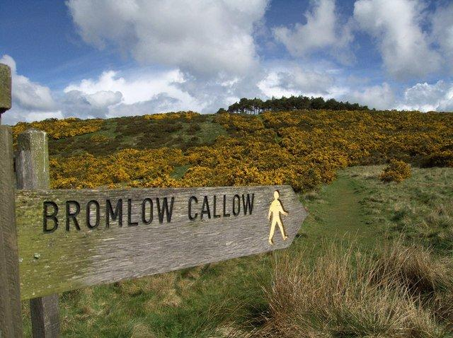
Tourism
Tourism within the Parish relies upon our unspoilt natural features – a large part of the Parish being in the Shropshire Hills Area of Outstanding Natural Beauty (AONB). The primary assets are the scenery, wildlife and access to footpaths.
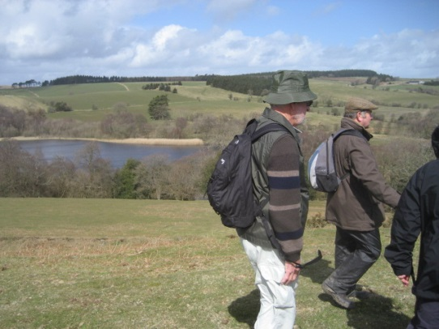
Accommodation is provided in local pubs and inns, by small Bed & Breakfast accommodation, and self-catering across a number of usually small cottages which have been converted from other use or newly built. A unique point of our area is that the small scale of accommodation provides a low level of groups so it is renowned for its peace and the ability to trek unhindered by great masses.
The Bog Visitor Centre is at the base of the Stiperstones range and serves drinks and cake, together with local crafts, all staffed by local volunteers. Over a season (Easter to end of October) 18,000 visitors pass through annually showing the scale that outdoor tourism plays in the local economy.
In addition to the facilities right on our doorstep, the local area is within reasonable reach of major towns such as Ludlow and Shrewsbury, while local market towns offer markets and shops. Major visitor attractions such as Stokesay Castle, Powis castle, Ironbridge Gorge and Attingham Park are all within easy reach offering the visitor a range of experiences.
85% of respondents see tourism as an important part of the local economy. 60% believe that Parish Maps showing walks and points of interest will encourage more tourism, whilst 22% believe that additional facilities for cyclists would benefit tourism. 18% consider that additional accommodation would benefit tourism.
A few suggest refreshments or café, many of the additional comments are in the Appendix.
43% of respondents believe that the signposting of public rights of way are inadequate.

All respondents believe that public conveniences should be maintained or provision increased. In Worthen 1 in 3 people believe that public conveniences should be provided, to replace the toilets removed a few years ago.

Actions: Explore the option of producing parish based maps for tourists
Explore the option of setting up a parish paths partnership group to improve footpath signage
Understand the correct level of required tourism accommodation using the Shropshire Council survey
Investigate re-instatement of public toilets in Worthen
Transport
As the Parish Plan questionnaire was sent out there were cuts to a number of scheduled bus services (Shelve and Bentlawnt lost their service entirely), and these have continued into the 2013/14 financial year with reduction of Shropshire Council subsidy, and closure of the Shropshire Link service.
Great effort was made to try to capture data across all the bus services through the Parish, with the core data shown in the Appendix. With the reduction in bus services there is increased reliance upon use of private transport, which in turn increases costs for those wishing to live in the country but needing to commute for work.
Shropshire has been shown to be amongst the top 10 counties within England for number of potholes. The Parish Council frequently notify the Highways Department about areas of particular concern. There are many comments regarding the speed of traffic on small roads, the lack of strengthened verges, and the problems for pedestrians.
The most widely used bus service is the 552/553 Shrewsbuy to Bishops Castle with 82 using it sometimes, followed by 558 Shrewsbury to Montgomery used by 59 people, Stiperstones Shuttle (summer only) 29, 745 service 25, and Thursday Market service 18, with Shropshire Link having 11 users. However only the 552/3 service attracted more than 15 regular passengers on any day, with 16 travelling on Thursdays.
Respondents were equally divided as to whether there was sufficient service, but 77% did think it was good value.

Figure 22 What car scheme would the respondents support and use
A variety of options were given to respondents regarding various methods of pooling private transport. Only about 15% actually responded to this question (68 total responses, due to possibility of multiple choices) so any scheme would be starting from a low awareness base. Similarly only 3 people out of 152 who responded actually used the Shropshire Link bus service, showing the need for continual promotion of any service which may be used only sporadically.
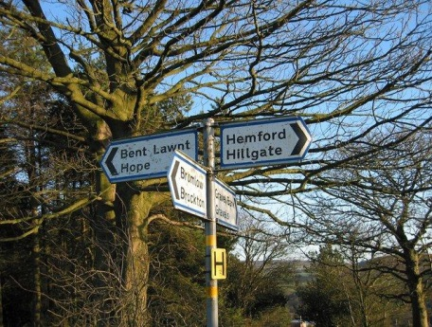
Figure 23 Level of respondent’s satisfaction with highways
*Note there are higher expectations in these areas in the Heath and Hope Wards.
With regard to passing places, both Heath and Hope Wards have higher requirement for formal arrangements - 52% and 48% are in agreement.
And with regard to grit bins Heath Ward has a higher satisfaction of 62%.
37% of respondents from Worthen Ward identify more parking spaces required, at the shop and village hall in Worthen and in Brockton.
For details see appendix Q 54,5 and 7. Example comments are:
“From the approach to Londis from Little Worthen side to Brockton. The hill and the bend are very dangerous especially when lorries are unloading at Londis, and people travel much too fast without any consideration to pedestrians”
“’patching up’ on a yearly basis is inadequate. Re-laying of roads required, to cater for increased HGV usage”
“A grit bin is needed between the end of Oakfield and the start of Hawthorns”
“There should be a speed limit on the Hope Valley”
“Top of Bromlow bank on the corner & half way down to Callow Inn. Grit bins reqd. If we get more tourists, more passing places may be required. The school bus run from A488>Gravels Sq>Bentlawnt is never gritted”
“Between Plox Green and Stiperstones as the buses and tractors are slow, there is an accident waiting to happen”
“Roads eroding in Snailbeach due to heavy use by buses/lorries. Formal passing places are required especially in Stiperstones/Snailbeach due to Minsterley Motors Coaches”.
Actions: Provide additional grit bins where required
Inform Highways of areas where repairs are needed
Promote enforcement of current speed limits
Support requests for traffic calming where asked
Actively promote any community transport system
Research possibility of car sharing schemes

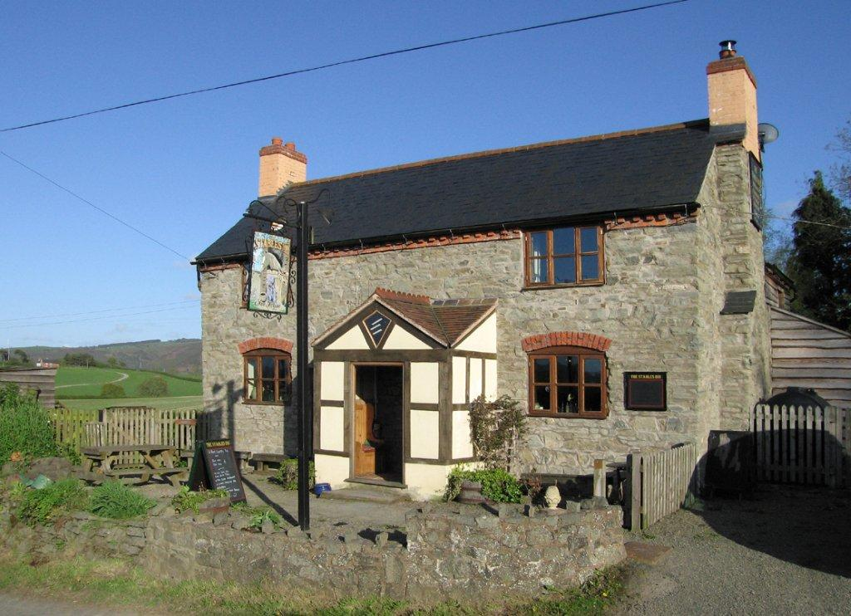

This plan was adopted by the Parish Council on 27 January 2014

Many thanks to the following for contributing to the production of the Parish Plan.
John Beecroft
Joan Beecroft
Helen Fairweather
Paul Davis
Jerry Hughes
Heather Kidd
David Smith
Annabel Stacey
Matthew Mead
Fiona Dale
John Soper
Elaine Uttley
Dave Croker
John Pattenden
Caroline Jones
Sarah Crossland
Sara Botham
Sarah Roberts
John Gorman
Jon Newson

The Stables Inn and The Stiperstones Inn
And to all members of the parish who contributed through meetings and the questionnaire.

Appendix

Implementation Plan
Issue | Action | Responsible Partner | Timescales
Housing and Development | Ensure Local Implementation Plan reflects local housing needs, encourage developers to work within that plan  Encourage renovation and redevelopment over green-field use  Promote smaller houses (2 &3 bedroom) in small speculative infill sites | Shropshire Council  Parish Council | Annual Updates  Ongoing
Community Infrastructure Levy | Encourage community schemes beneficial for locals by requesting ideas for funding  Support village halls | Local communities  Parish Council | Issue annual appeal for ideas  Ongoing
Facilities for Children and Young People | Encourage provision of pre-school and after-school clubs, and holiday provision.  Investigate setting up Youth Club in Stiperstones | Local communities  Primary schools | Ongoing
Employment and Training | Improve local training opportunities through Landscape Partnership  Assist youngsters find suitable work by setting up a mentoring scheme | Stiperstones & Corndon Hill Landscape Partnership | 2013-2018
Leisure and Recreation | Improve access to play facilities in Hope and Stiperstones  Upgrade Village hall facilities so that more groups feel able to use them | Local communities  Village hall committees | Ongoing
Communications | Lobby for improved Broadband services, TV, radio and mobile phone coverage | Switch on Shropshire, BDUK  Unitary Councillor | 2013-2014
Sustainability and the Environment | To press for improvement in Broadband so that home working is possible  To provide recycling facilities to complement kerbside recycling  Implementation of power-saving measures for street lighting  Promoting local and national tree-planting schemes  Promoting facilities for small scale business development  Promote locally grown and sourced produce through “buy local” | Switch on Shropshire, BDUK  Unitary Councillor  Shropshire Council  Parish Council  Shropshire Council tree scheme  Shropshire Council  Farmers Markets at Stiperstones, Hope Schools, Local communities | Ongoing
Community Services and Activities | Promote cultural activities across the Parish by using the Parish website to provide a calendar  Encourage local activities in the Village Halls  Provide improved sporting activities | Parish Council website  Village hall committees  Local communities | Up & running by end of 2013  Ongoing
Crime and Safety | To press for further speed limits to improve road safety  To disseminate information on Rural Watch  To improve reporting of problematic activity like anti-social behaviour and drug abuse | Shropshire Council  Parish Council  West Mercia Police  Local communities | Ongoing
Healthcare | To support Worthen in developing a new surgery  To support the provision of additional healthcare in the Parish | Worthen Surgery  Shropshire Council | Complete by end of 2014  Ongoing
Footpaths and Pavements | To lobby for improved pavements where identified  To explore the option of setting up a parish paths partnership group to improve footpath signage  Provide additional signposted circular walks | Submissions to Safer Roads scheme  Shropshire and Parish Councils  Shropshire Council  Local communities | Submitted 2013  We are hopeful that local groups will undertake this
Tourism | To explore the option of producing parish based maps for tourists  To explore the option of setting up a parish paths partnership group to improve footpath signage  To understand the correct level of required tourism accommodation using the Shropshire Council survey | Local communities  Parish Council  Local businesses | We are hopeful that local groups will undertake this
Transport | Provide additional Grit bins where required  Inform Highways of areas where repairs are needed  Promote enforcement of current speed limits  Support requests for traffic calming where asked  Actively promote any community transport system | Shropshire Council Highways  Parish Council  West Mercia Police  Local communities | Ongoing

LOCAL IMPLEMENTATION PLAN ADOPTED BY WORTHEN WITH SHELVE PARISH COUNCIL
Adopted by Worthen with Shelve Parish Council on 28th January 2013. This plan is to be reviewed on an annual basis. Reviewed and updated on 25th July 2016 (minute ref: 748 4b).
Wards as a whole are not permitted to be included as a cluster. Therefore, named settlements in the parish have been included in the Cluster for new open market housing. Please see table below.
In order to enrich our local communities in terms of providing houses, new properties should not be solely concentrated in the larger villages, but should encompass all settlements. Each ward has been allocated with specific MAXIMUM numbers of open market housing and development size.
The future housing stock should provide properties to enable downsizing within our communities, thus freeing up family homes. In addition, good value small family homes are required rather than executive accommodation as there is an abundance of these property types in the parish. The Parish Council would like to see two and three bedrooms properties as a priority. A maximum floor area should be 100 sq metres. Any new social/affordable housing which is built must be designated for people with a proven local connection to the parish.
The Council will not allocate development sites and land will not appear on the SHLAA as the Parish Council wish to be able to maintain the right to allocate affordable housing to local people. We do not want an allocated development boundary as our preferred option is for infill housing and single plot development.
The majority of the community via the Parish Plan, community events and specific feedback to councillors opted against large development sites and estates. In addition 75% of the parish population indicated via the Parish Plan Questionnaire that the field in-between Brockton and Worthen should be retained as a buffer zone with no housing. A community building may be considered.
The majority of the parish is located in and/or overlooked by the AONB . This must be taken into consideration when new development is proposed, in particular, domestic and commercial wind turbines and solar panel fields. Therefore, to ensure the landscape is not damaged by overdevelopment of unnatural features, solar panel fields should not be introduced within the parish. Proposals for wind turbines and associated infrastructure within the Parish should take into consideration the landscape character, visual amenity and overall sustainability and commercial/community. Therefore, turbines of over 25m to tip will not be permitted. The cumulative impacts of all wind turbines should be a consideration when applications are submitted and groups are not likely to be acceptable. Turbines should be sensitively positioned and no more than one turbine should be visible from any point. We strongly urge any applicants to approach the Parish Council directly before an application is submitted.
The current CIL priorities agreed at the Parish Council meeting on Monday 27th January 2014 have been identified as support for all village halls in the parish (which provide accommodation for most community, young people and youth projects in Worthen with Shelve), safe pavements in Stiperstones and Brockton/Worthen and public toilets in Snailbeach
Page 1 of 2

- 2 -
LOCAL IMPLEMENTATION PLAN WITH SPECIFIC DETAILS FOR EACH WARD
(UP TO AND INCLUDING 2026)

WORTHEN | HOPE & SHELVE | HEATH
The total number of open market housing in this ward, to encompass all settlements, not just Worthen and Brockton is 30. There will be a maximum development rate of 10 houses per 5 year period and there will be no new development sites with more than 5 properties in total.  The preference of this council for this ward is for infill housing and redevelopment of existing sites.  In order to maintain the street scene of the area bungalows would be preferential. | The total number of open market housing in the ward, to encompass all settlements, not just Bent Lawnt and Hope is 15.  The preference of this council is for infill.  A maximum development site will be no more than 2 properties.  There will be a maximum development rate of 5 houses per 5 year period. | The total number of open market housing in the ward, to encompass all settlements, not just Snailbeach and Stiperstones is 15.  The preference of this council is for infill.  A maximum development site will be no more than 2 properties.  There will be a maximum development rate of 5 houses per 5 year period.
Named Settlements:  Worthen, Brockton, Little Worthen, Little Brockton, Binweston, Leigh, Rowley, Aston Rogers and Aston Pigott | Named Settlements:  Hope, Bent Lawnt, Hopesgate, Hemford. Shelve. Gravels (incl Gravels Bank), Pentervin, Bromlow, Middleton, Meadowtown and Lordstone. | Named Settlements  Snailbeach, Stiperstones, Pennerley, Tankerville, Black Hole, Crows Nest and The Bog.

The low satisfaction in Hope was recorded before the new headteacher made numerous improvements to the school.
note – at the time of writing this document National Grid have announced selection of an alternative route rather than through this parish
Following the questionnaire the Parish Council submitted some areas for footpath improvement, but most have been turned down because the road is too narrow.
The new Worthen doctors’ surgery should release some parking spaces at the Village Hall when completed.

